**DAILY ONLINE ACTIVITIES SUMMARY**

|  |  |  |  |  |  |  |  |
| --- | --- | --- | --- | --- | --- | --- | --- |
| **Date:** | **29-05-2020** | | | | **Name:** | **Gudugunti Anirudh** | |
| **Sem & Sec** | **IV - A** | | | | **USN:** | **4al18cs023** | |
| **Online Test Summary** | | | | | | | |
| **Subject** | | **Operating Systems** | | | | | |
| **Max. Marks** | | **30** | | **Score** | | **29** | |
| **Certification Course Summary** | | | | | | | |
| **Course** | **Python in ML** | | | | | | |
| **Certificate Provider** | | | **Great learning academy** | **Duration** | | | **2hrs** |
| **Coding Challenges** | | | | | | | |
| **Problem Statement:** 1. Write a Java program to Find size of the largest ‘+’ formed by all ones in a binary matrix | | | | | | | |
| **Status: Uploaded** | | | | | | | |
| **Uploaded the report in Github** | | | | **Yes** | | | |
| **If yes Repository name** | | | | **https://github.com/Anirudh23-23/Daily-progress** | | | |
| **Uploaded the report in slack** | | | | **Yes** | | | |

Online Test Details:

**OS:** The online test was from module 2 which was about Multi-threaded Programming. There were 30 questions and the duration was 45 minutes. The questions were optimal and were easy. 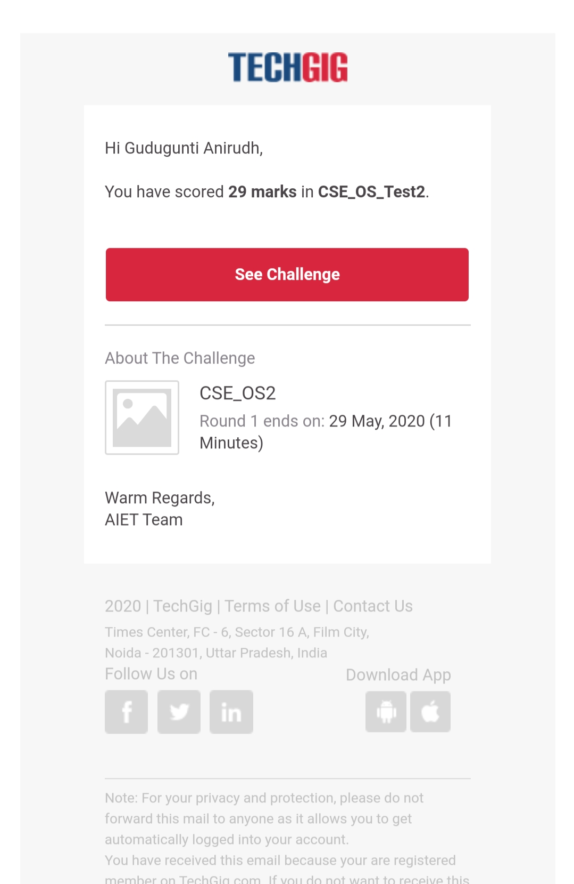The score that I got in the test is 29/30.

Certification Course Details:

1. Introduction to pandas.

2.Pandas is a package used for managing data.

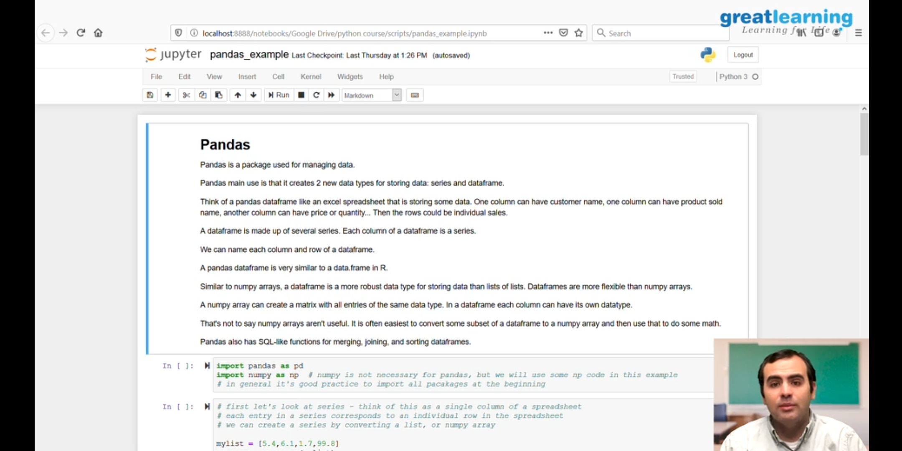

3. The main use of pandas is that it creates 2 new data types for sorting data like:series and data frames.

Coding Challenges Details:

Problem 1: (using java) Write a Java program to Find size of the largest ‘+’ formed by all ones in a binary matrix.

